
Issue 5 09/08/17
FI070 FITTING INSTRUCTIONS FOR RTR7122 SERIES TR4, 4A, 250, 5 and 6
FIBREGLASS REAR BACK LIGHT FRAME WITH INTEGRAL ROLL OVER BAR (ROB), RTR7267 SERIES FULL CAGE, RTR7153 WITHOUT INTEGRAL ROLLOVER BAR AND RTR7172F FIT UP KIT.
THIS INSTRUCTION ALSO COVERS ROB’S RTR9148 SERIES AND FULL CAGE RTR9177 SERIES WHEN FITTED WITHOUT A BACKLIGHT FRAME.
NOTE 1: RTR7122 and RTR7267 series kits incorporate a lightweight backlight frame which uses the Roll Over Bar (ROB) for its strength, RTR7153 is a more substantial fibreglass construction and is intended to be free standing. These instructions should be followed for both types of instillation, omitting the Roll over bar instructions for the RTR7153 type. Likewise when a ROB is being fitted without a backlight frame, the backlight frame instructions which are not relevant can be ignored.
NOTE 2: Whilst this backlight frame arrangement would originally have been fitted to TR4, 4A, 250 and 5 it not uncommon for the arrangement to be fitted to TR6 as well. All the instructions relevant to a TR250 or TR5 apply to a TR6.
NOTE 3: The RTR9148 series ROB which forms part of the integral backlight frame package was not initially envisaged as being supplied separately. However he have been asked frequently to supply these on their own. Typical installations would be: - under a standard aluminum backlight frame, a none-Revington TR fiberglass back light frame, under an aftermarket complete roof assembly or in a race application with no roof at all. As a consequence these fitting instructions have been altered to accommodate these eventualities.

DESCRIPTION:

RTR7122 series. Fibreglass backlight frame; incorporating an integral ROB.
This arrangement provides a new lightweight fibreglass backlight frame incorporating an integral ROB with two backstays.
The fibreglass backlight frame is fixed to the ROB with 2 countersunk screws making one integral assembly.

RTR7267 series. Fibreglass backlight frame; incorporating an integral full cage part number RTR9177 (see drawing JNR0267 at the end of these instructions).
This arrangement provides a new lightweight fibreglass backlight frame incorporating a full integral Roll Over Cage (ROC) with two backstays, which connect to the chassis, a front hoop, two door bars and two roof bars.
The fiberglass backlight frame is fixed to the ROC with 2 countersunk screws making one integral assembly.
RTR7153 series. Fibreglass backlight frame with no ROB.
This backlight frame incorporates additional layers of fiberglass and is intended to be free standing, not requiring additional support. This arrangement is indistinguishable from the original frame assembly when painted and finished.

PREPARATION:
Remove the hood and frame or existing Backlight frame.
TR4 owners: Remove the 3 tonneau finishers and hood studs. (Soft-top cars only)
TR4A-5 owners: Remove 2 ‘B’ Post finishers secured by a hood stud along with 2 other hood studs on the LH and RH forward tonneau panels. (Soft-top cars only)
Where a TR4A or TR5 has not had a backlight fitted before, the tonneau panel should have 5 captive nuts (rivnuts) around the forward edge of the rear tonneau panel. These need to be removed by drilling out leaving only plain holes in the panel with rivnuts completely removed.
Remove the internal quarter panels and tank board in the cockpit. Remove the seats and carpets.
To remove an existing backlight frame, remove the two side trim panels in the backlight frame to reveal 2 nuts and washers on 2 studs. Remove the nuts and washers leaving the studs in place.
Remove nuts and washers from the 7 studs which hold the backlight frame down onto the tonneau panel. The frame should now lift off.
NOTE 4: Most of the parts from an existing backlight arrangement can be reused with this new arrangement. If an original backlight has not been removed, then a fit up kit will be required. 3 are available as follows: -
RTR7172G Fit up kit including a glass window. Please note that glass is not always available so Flexiglass may be the only choice. Please enquire for the current position. Revington TR consider the Flexiglass option to be best as it is light and transmits more light than glass. The kit includes all rubbers and fittings.
RTR7172F Fit up kit with Flexiglass window. The kit includes all rubbers and fittings.
RTR7172X Fit up kit with no window. The kit includes all rubbers and fittings.

ASSEMBLY:
The backlight frame attaches with 2 studs protruding up from the top of the ‘B’ Post, 2 more studs down the side of the side tonneau panels, and 5 more studs protruding downwards from the backlight frame into the rear tonneau panel.
The 2 side studs pass by the side tonneau panels on the inside (TR4A-5), but usually interfere. Triumph, when fitting backlight frames to these cars would simply deform the body (with a hammer) if this were a problem. (It’s true honestly). This therefore must be done if the studs will not easily pass inboard of the bodywork. The backlight frame in this position is then attached to the forward tonneau panel with a ‘U’ shaped bracket, rather like a square washer with two edges turned up. This ‘washer’ is passed over the stud and is secured with a plain nut and spring washer. The forward tonneau panel on the TR4 is wider and the studs pass through a hole each side. If there is no hole, drill 8mm.

At the 'B' post top, revealed by removing the aluminum finishers, are captive nuts, which will accommodate two studs. These were present on all TR4-6 shells irrespective of whether a hard top was fitted or not. With so many cars having being rebuilt these days it is possible these captive nuts are not present on your car. If a plain hole is found (or no hole – drill 7mm diameter, 13mm from the front edge of the flat part of the raised section of the forward tonneau panel, to line up with the pilot hole in the front of the backlight frame) insert a ¼”UNF x 1-1/2” screw with ¾ O/D washer from below securing above with ¾” O/D washer and nyloc nut above. Alternatively a suitable captive nut can be riveted or welded in place.

Fitting the backlight frame
Insert 2 studs into the 2 captive nuts in the 'B' post top positions.
Trial fit the backlight frame with the seal to the body in place. As the backlight frame will be removed repeatedly whilst trial fitting, the seal should be glued in a few strategic places with superglue. To assist fitting the seal around the forward edge, where the seal needs to pass through 90 degrees, cut a section out of the inside of the seal where the corner is.
DO NOT exert excessive force whilst trying to locate the studs. Relieve the holes in the tonneau panel of the car if necessary so that the backlight frame easily drops on.

As mentioned before, TR4A-5 owners will note that there are no holes for the two side studs. These fit down the inside of the forward tonneau panel and may be tight, requiring the edge of the tonneau panel to be dressed outwards slightly. (This is standard procedure for TR4A-5 cars when fitting a backlight frame).
At the B post drill out the pilot holes in the backlight frame to allow the studs to pass through. These holes may need to be filed out to allow for best fit with respect to the door glass.
Offer up the backlight frame once more and ensure the frame drops easily onto the car.

FITTING THE ROB
Slide on the main hoop feet and back stay feet to the main bar and offer into the car.
Pull up the ROB so that it sits snugly under the backlight frame.
Hold the ROB to the backlight frame with tape. Make sure the ROB is up tight in the backlight frame but not splaying it.
Position the legs of the main hoop for best fit ensuring there is an equal gap to the upper ‘B’ Post. Drill the lower wheel arches (one hole each side at this stage) to bolt through. Consider also the gap at the B post, which should be sufficient to allow the inner casing to be refitted. If the gap is too little, temporarily space the main legs off the B post. If too much, splay the legs until the gap is correct.

Now ensure the main feet can line up with the square floor indent. It may be necessary to relieve the outer edge of the footplate to clear the base of the ‘B’ Post. Leave the backstay feet in place but unattached at this point.
Tighten down the main hoop feet sufficiently to hold them to the body ensuring that the upper part of the hoop does not lose its position. TR4 cars use longer chassis bolts (5/16”UNF- not supplied in the kit) via aluminium packers, into the chassis. TR4A-5 cars use 10mm bolts supplied via aluminium packers to the nut plate under the floor. It may be necessary to lift the floor or even drill through the top face of the chassis to allow the nuts on the nut plate to drop into the chassis. There is not much room between the body and the chassis at this point. Where the car is being prepared before painting, holes large enough to accept the M10 nuts can be drilled in the floor and the nut plate welded on top of the floor in the recess. If this is done then the aluminium packers may not be necessary.

It is important at this point to establish that the rather flexible backlight frame is sitting correctly.
Observe the following:
a/ The front edge of the frame should be in line or just forward of the top edge of the B post. Wind up the windows and gauge the gap required.
b/ The outside edge of the backlight frame, at the B post should be inboard of the chrome strip sufficiently to allow the seal below the backlight frame to sit just inside the chrome strip.
c/ It is unlikely that the lip, which takes the furflex, will line up exactly with the same lip on the body. Usually the body lip is inboard of the backlight frame lip.

d/ For reference the distance between these lips at the base of the backlight frame should be approximately 1135mm.
e/ Trial fit the hardtop roof (if you are fitting one) to establish that you will be able to fit it later. Repeat this step whilst fitting the roll bar, bolting on the hardtop via the countersunk screws, to ensure the roof will continue to fit.
f/ Trial fit the glass/Perspex and seal.
g/ Trial fit the Surrey top if one is being used. (In correct triumph speak the Surrey top is the cloth cover)
h/ Look at the windscreen angle and the door glass angle. These may need adjusting too.
i/ The back light frame may have deformed in storage. Be prepared to exert a little force to pull the backlight frame sideways to provide a parallel gap to the door glass.
All of the above may have to be compromised for best fit to individual cars.
Repeat these checks throughout the fitting of the backlight frame and roll over bar.
Time spent ensuring everything will fit, as assembly progresses will save time during use when the roof panel and Surrey top should simply drop into place.

It may be necessary to allow the rear lower edge of the backlight frame to float freely at this stage by removing the 5 rear nuts and loosening the two side nuts, leaving the two ‘B’ Post nuts tight, as the upper part and the ROB may need to be pulled forward to allow the hardtop to fit, or to improve the gap at the door glass rear edge. In tests at Revington TR we have observed gaps at the rear of the door glass ranging from 10mm to 25mm on cars with factory fitted backlight frames. If the rear edge is allowed to float freely then once fixed to the ROB with the countersunk screws it can be retightened to the tonneau panel.

Be aware whilst doing this that the backlight window (glass or flexiglass) will need to be check fitted with its rubber to ensure the distance from top to bottom is not stretches such that the window will not fit
As the holes at the forward edge (B post) of the backlight frame will have been filed out to provide best location, it is now useful to set the correct position for this. Place a rubber buffer over the stud at each side with some cling film over it. Fix a ¼” I/D washer inside the backlight frame with some resin and chop strand fibreglass material. This will be used again later. Offer the backlight frame into position and lightly secure in the desired location with a washer and nut. As the backlight frame is most likely to need to be pulled in towards the centre of the car, it can be temporarily secured with tape to the ROB.

FITTING THE ROB FEET
Once satisfied, ensure the feet of the main hoop are slipped into the base of the mail hoop.
Ensure the Hard top, if one is to be used, is to hand during this part for continuous trial fitting.
Drill through the upper wheelarch and bolt down the backstay feet. Recheck the fit of windows, roof, surrey cover etc. as the next step is final!
Drill through the main hoop base and foot via the pilot holes to 8mm clear and secure with 2 off 8mm screw and nuts. Repeat this exercise for the backstay feet.
Drill the remaining 4 holes though the wheelarch base for the main hoop attachment.

FITTING THE ROB SIDE SUPPORTS
The ROB supports the B posts via two side attachments. Position the ‘L’ shaped brackets behind the ROB brackets and bolt together with sufficient washers between the parts to simulate the space required for the quarter panel. Weld the ‘L’ shaped bracket to the inside of the B post.

FITTING THE BACKLIGHT FRAME TO THE ROB
It is now necessary to fix the backlight frame to the ROB upper hoop. To ensure the backlight fits snugly onto the ROB and is not crushed when secured with the two 14mm countersunk screws, three fiberglass resin saddles need to be built between the bar and the fibreglass backlight frame: two where the screws will go and one in the middle to prevent the frame from deforming if leant on.
To achieve this you will need: -
• A minimum of ½ litre of polyester resin with chopped strand filler. RTR can supply part number PPA21; a 1 litre tub.
• Some 'cling film'
• Plasticene
Proceed as follows: -
Insert the 14mm screws from below and drill a pilot hole up through the ROB through the backlight frame top face. Open out these holes to approximately 15mm so that the 14mm countersunk screw can be screwed through the backlight frame into the ROB. Attach the backlight loosely to the ROB with the 14mm counter sunk screws just enough to hold it in place but not enough to deform it and check the installation especially with the hard top secured to the windscreen and via the backlight frame countersunk screws.

Temporally remove the backlight frame and open out with a large countersink cutter the two holes to the head size of the counter sunk screws. Care is required here to ensure the holes in the backlight frame are countersunk just enough to accommodate the screw, and only just large enough for the screw to sit flush with to 1mm proud of the top of the backlight frame (without falling through).

Wrap the ROB with one thickness of cling film at least 80mm either side of each 14mm threaded boss.
Using plasticine form a barrier 45mm either side of the 14mm boss on the upper surface of the main hoop.
Form walls of plasticine between these barriers to enable a pool of resin/chopped strand to be made. This will prevent the fibreglass resin from escaping.

Make a similar but smaller barrier of plasticine in the middle of the bar. This one need only be 30mm long and when filled with resin will form a midway support for the backlight frame.
Now mix sufficient resin and catalyst for 3 bridges and spoon into the well of plasticine, ensuring enough resin is introduced for a firm bridge to be made when it hardens.

Ensure that not too much hardener is used to ensure adequate time for assembly.
When sufficient is in place offer the backlight frame onto the ROB once more, tighten the studs holding the backlight frame to the B post with care as before.

Once more lightly tape the backlight frame to the ROB. Ensure that the bar and backlight frame are securely taped together with the bar nestled snugly into the frame without spreading it. Through the top holes in the backlight frame, ensure enough resin is in place, pushing the resin to the side to expose the central tapped hole. Add resin as required.
Introduce the two countersunk screws, sparingly wiped with very thin oil and screw these into place from the top, with just enough force to form a seat with the top of the screws flush with, to 1mm proud of, the top of the backlight frame.
Leave the assembly for the resin to reach its 'green' state. This is when the resin is solid but not quite hard.
At this point extract the counter sunk screws. This will ensure they are not stuck fast, which may be the case if left until the resin is hard.

Remove the back light frame once more and trim off excess resin whilst in the 'green' state. Ensure no extra resin is left on the thin lip of the backlight frame as this will impede the fitting of the backlight glazing seal and the furflex finisher.
A countersink in the top of the backlight frame will have been formed so that the countersunk screws will sits flush with the top of the backlight frame. Remove the cling film from the ROB.

Once satisfied that the backlight frame can sit in the desired position, the rubber support pad thickness needs establishing. These pads sit over the backlight attachment studs to provide positive support.
Make 7 even rings from Plasticene 6mm high and place these on the rear deck over the mounting holes. 2 more are needed at the B post studs but these need to be 15mm high.
With the seal in place, pull down the backlight frame evenly with plain ¼ UNF nuts and washers so that it sits down evenly over the tonneau panels. Do not over tighten as the studs can be pulled off!
Remove the backlight frame and assess the size of the rubber pads needed.
Cut the rubber buffers supplied to the sizes indicated by the Plasticene and glue these under the backlight frame, over their respective studs.
For a final check, once more attach the backlight frame to the car with washers and plain nuts. Do not over tighten.
Remove the backlight frame for painting and remove any remaining cling film and plasticine from the backlight frame and ROB. It is recommended that the inside be left untrimmed, but painted Satin black due to the proximity of the ROB.

Once painted trim the backlight frame (non ROB type only)

Refit the backlight frame and secure with ¼” I/D x 5/8”O/D washers, spring washers and plain nuts (2 off ¾” washers are used at the B post studs). TR4A-5 owners may wish to bend two washers into a ‘V’ shape to catch the edge of the tonneau side panels in two positions.

Reattach the backlight frame to the ROB with the two countersunk screws.
Fit the glass/Flexiglass, glazing rubber and finishing strip. When using Flexiglass it is strongly recommended that the window be permanently glued in with modern windscreen attachment glue.
Refit the interior trim and seats.

SPECIFIC INSTRUCTIONS FOR FITTING THE Roll Over Cage
Follow the instructions for fitting the ROB main hoop in principle but note that the feet of the ROC main rear hoop are welded on. It may be necessary to pack up the main hoop with aluminum packers supplied to gain a snug fit between the backlight frame and the floor. See drawing JNR0267 for reference. The nut plate shown under the backstay foot in drawing JNR0267 are for use with TR4A-6 chassis. The rear hoop foot is bolted directly to the TR4 chassis.
Loosely attach the backstay between the firewall and the boot floor, drilling the appropriate holes. Loosely fit the lower backstay between the boot floor and the chassis. Offer up the two lower right-angled plates to the chassis and tack in place.
Offer up the front hoop with the dash panel removed. Offer up and bolt in place the roof and door bars. Ensure the hard roof panel will fit if one is to be used.

Once the cage is loosely bolted into the car, the various attachment points can be welded in place. The footplate attachment for the front hoop is assembled in situ. The flat plate lies on top of the floor with the aluminum packer taking up the space in the body to chassis attachment well. The right-angled nut plate sits on the inner sill (large holes need to be drilled in the inner sill to accommodate the welded on nuts). Once satisfied with the fit, the footplate and nut plate are welded together and welded to the floor. To attach the A post nut plate behind the bulkhead end panel, it is necessary to remove the front wings. If this is not practical, a suitably sized hole can be drilled next to the attachment position to allow the plate to be fed behind the bulkhead end panel. The nut plate can then be riveted in place.

Once completely fitted, you will find that with the door bars in place, it is impossible to wind up the windows with the door shut. Revington TR has a solution for this in the form of a ‘spider’ handle that will just fit between the door and the bar. Please order part number RTR7275K.

ROOF CENTER PANEL
The roof is secured from below the ROB with Hex screws and washers, clamping the backlight frame between ROB and roof panel. Standard fasteners secure the front of the roof panel.

FITTING THE CLOTH SURREY TOP
When fitting a surrey top follow either of the following instructions. The appropriate fitting instructions will be supplied when the kit is ordered.

FI0080 Fitting instructions for surrey top kit with fixed header rail TR5 and TR250 and TR4-4A with TR5-6 windscreen frame fitted, or
FI0097 Fitting instructions for standard type surrey top kit TR4-4A, TR5 and TR250.

In addition the following will need to be done.

To enable the Surrey top to be fitted to the fiberglass backlight frame it is necessary to ensure the large countersunk screws have been drilled out to 10mm, and to drill two holes into the front vertical face of the backlight frame.

PROCEED AS FOLLOWS: -
1. Countersunk Screws; Ensure these countersunk screws are drilled through 10mm. The Surrey top rear frame lugs rest in these holes and are secured with 2 cap screws from below.
2. Main Frame; to accommodate the main frame, 2 holes need to be drilled backwards into the forward vertical face of the backlight frame. Measure and mark two places symmetrically about the centreline of the backlight frame, 706mm between centres. This measurement is taken directly across, not following the contour of the backlight frame.
3. Measure 8mm from the top of the backlight frame to establish the horizontal centerline for drilling.
4. Lay the rear legs of the surrey frame on top of the backlight frame above the centreline drawn for the locating holes. Pencil a line either side of the frame thread onto the top face of the backlight frame to establish the angle at which to drill.
5. Remove the Surrey frame and using the penciled lines as a guide, drill 3mm pilot holes backwards into the resin bridges to a depth of 20mm. Open out these holes to 10mm diameter.

Be aware that these 10mm holes drilled into the resin bridge of the backlight frame might break through and hit the ROB. Be sure to stop short of drilling into the ROB.
Fit two stainless steel cover plates securing with 3 self-tapping screws each.

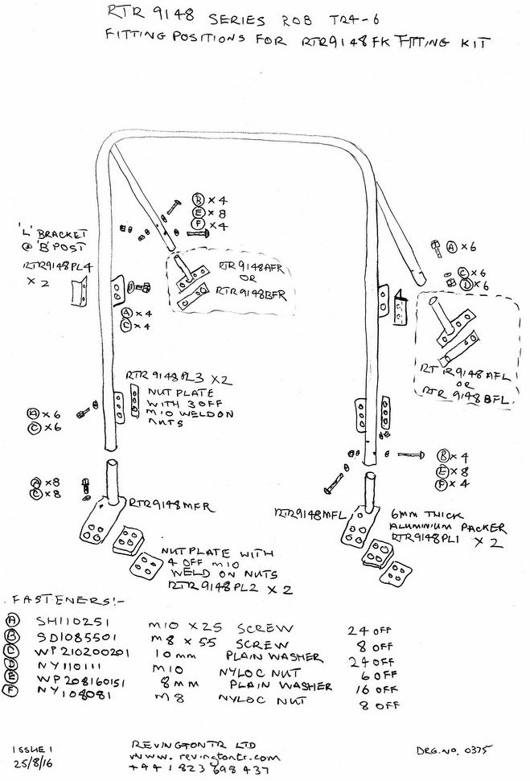

Figure 1 Roll Over Bar

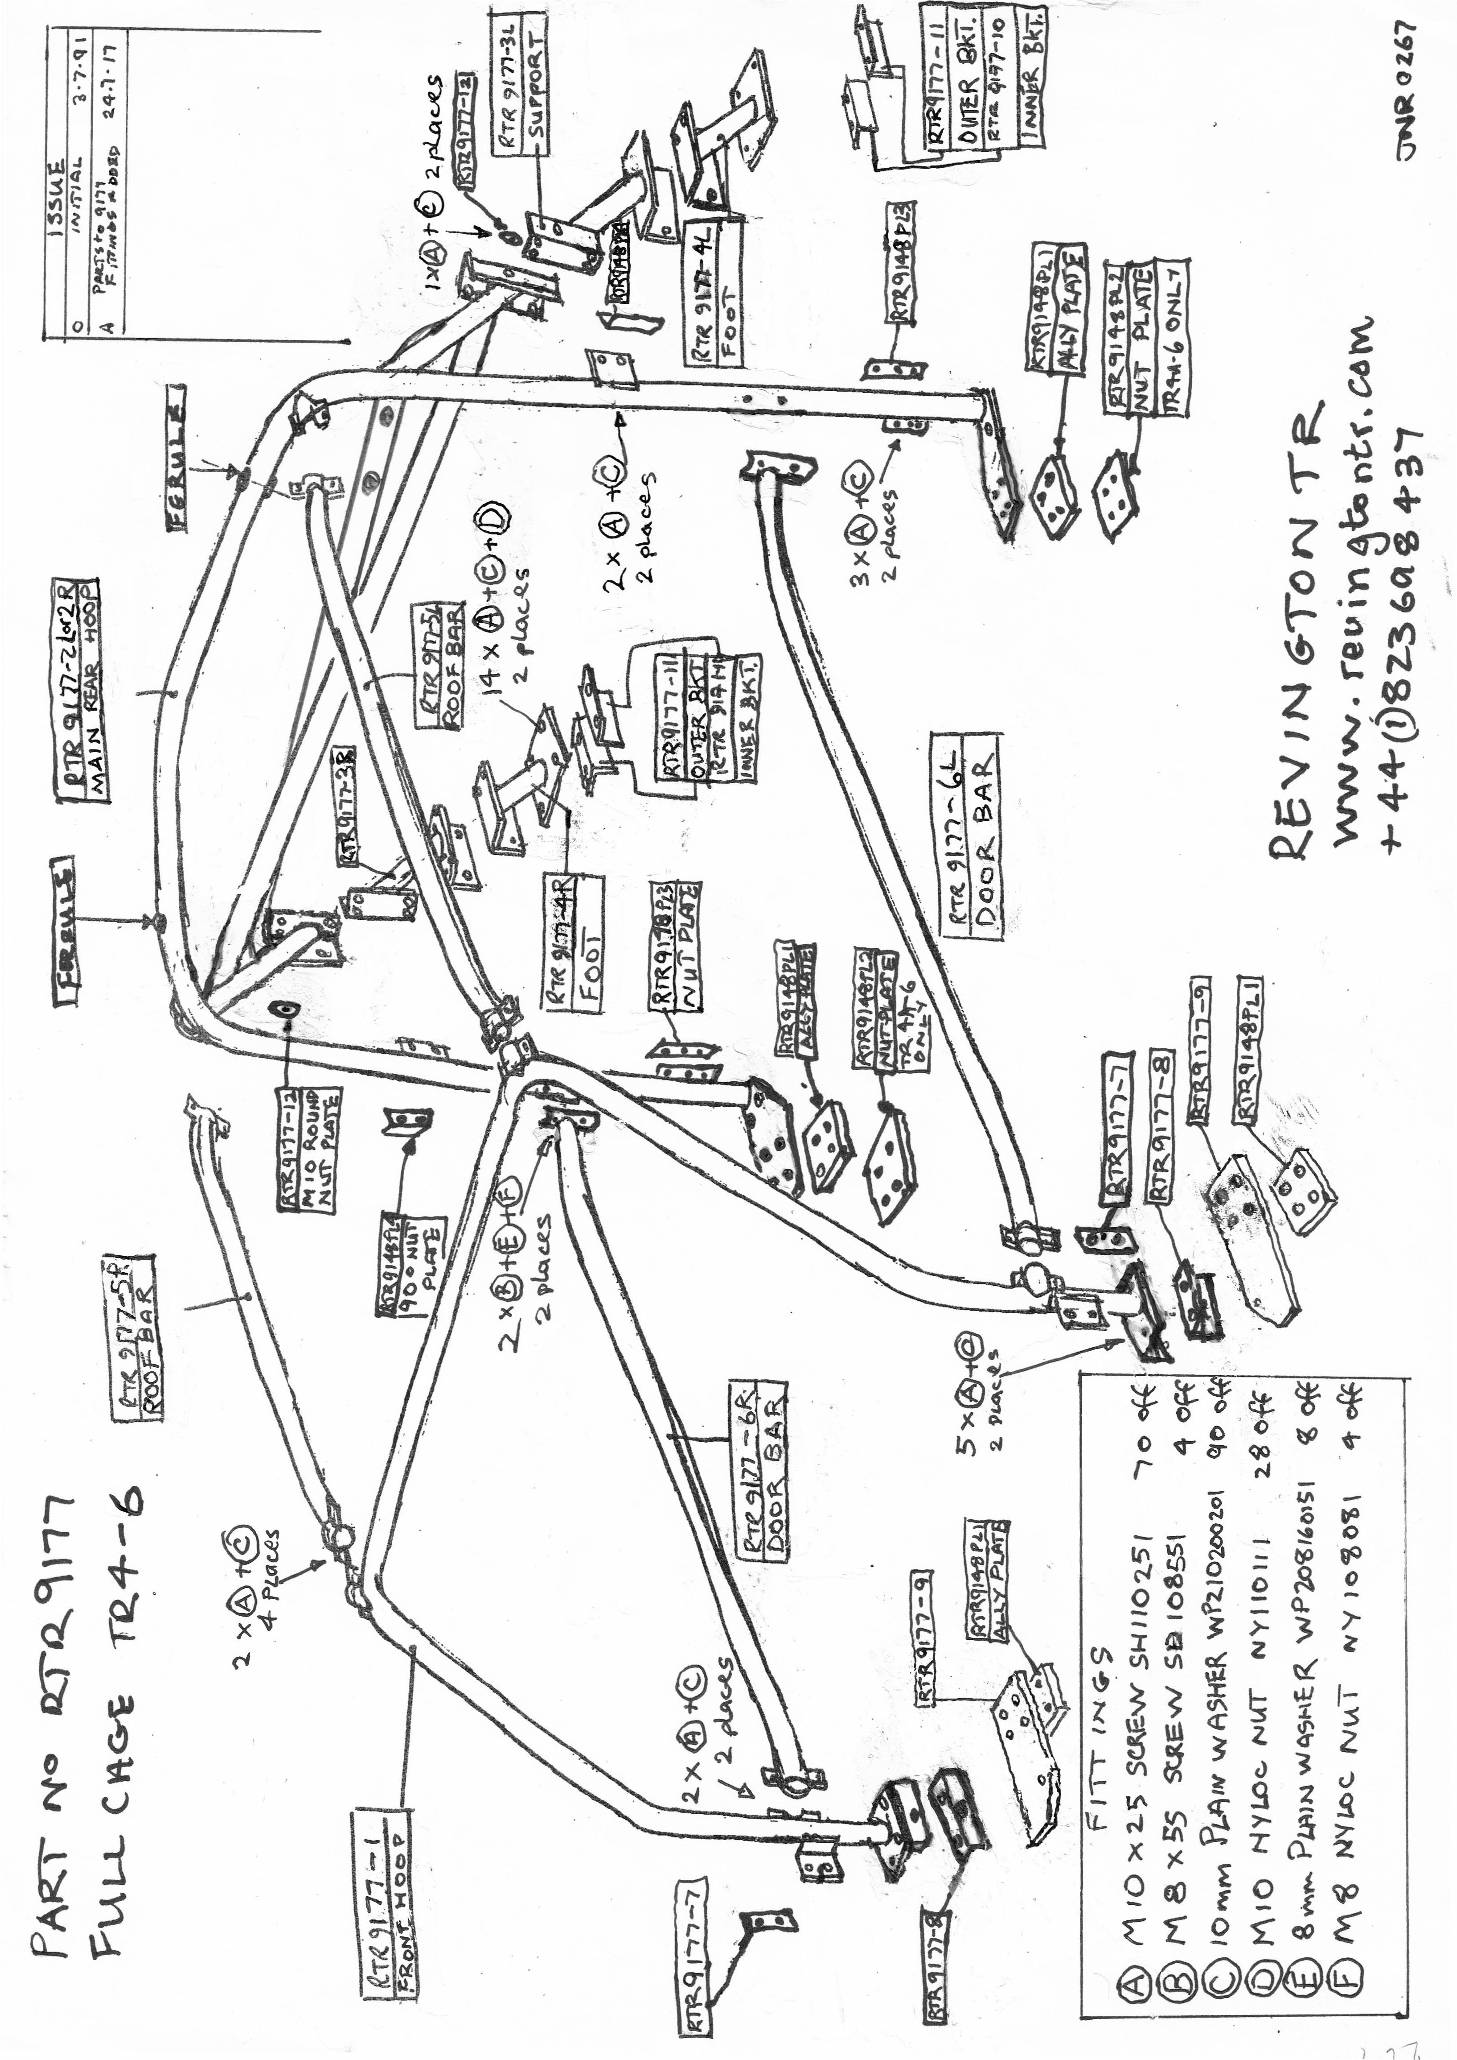
Figure 2 Full cage

email : info@revingtontr.com

International Phone
+44 (0) 1823 698437

International Fax
+44 (0) 1823 698109
Revington TR
Home Farm
Middlezoy
Somerset TA7 0PD
United Kingdom

Website : www.revingtontr.com
Workshop facilities cover general servicing through to full restoration.
Rally and race preparation.
P.I. systems maintained.
Sole sponsors of the Revington TR/TR Register Sprint and Hillclimb Championship.
Comprehensive parts manufacturers and suppliers for the entire TR series.
Worldwide export service.
Visa, Mastercard, Delta and Switch accpeted for instant service.
email : info@revingtontr.com

International Phone
+44 (0) 1823 698437

International Fax
+44 (0) 1823 698109
Issue 5 09/08/17
Revington TR
Home Farm
Middlezoy
Somerset TA7 0PD
United Kingdom

Website : www.revingtontr.com
Workshop facilities cover general servicing through to full restoration.
Rally and race preparation.
P.I. systems maintained.

Sole sponsors of the Revington TR/TR Register Sprint and Hillclimb Championship.
Comprehensive parts manufacturers and suppliers for the entire TR series.
Worldwide export service.
Visa, Mastercard, Delta and Switch accpeted for instant service.

